Experiment No: 10
Roshini M H
192512317
IoT-Based Smart Agriculture and Automated Irrigation Using Python (Google Colab)
Aim
To develop and simulate an IoT-based smart agriculture and automated irrigation system using Python in Google Colab that monitors soil moisture, temperature, and humidity and automatically controls irrigation based on soil moisture conditions.
Objective
The objective of this experiment is to simulate an agricultural environment using IoT sensor data. The system monitors soil moisture, temperature, and humidity and decides whether irrigation should be turned ON or OFF. The sensor data is displayed in a table and visualized using graphs.
Software Requirements
- Google Colab
- Python 3.x
- Random library
- Pandas
- Matplotlib
Theory
Smart agriculture uses IoT sensors to monitor environmental and soil conditions. Soil moisture sensors help determine whether crops require water. Temperature and humidity sensors provide information about the surrounding environment.
In this experiment, sensor values are simulated using Python. When the soil moisture level falls below a predefined threshold of 40%, the irrigation pump is switched ON. When the moisture level is 40% or above, the irrigation pump remains OFF.
This automated decision-making helps reduce water wastage and supports efficient irrigation.
Algorithm
- Start the program.
- Import required Python libraries.
- Generate soil moisture values.
- Generate temperature values.
- Generate humidity values.
- Set the soil moisture threshold to 40%.
- Check the soil moisture value.
- If moisture is below 40%, turn irrigation ON.
- Otherwise, turn irrigation OFF.
- Store sensor data in a DataFrame.
- Display the sensor data.
- Generate graphs.
- Display irrigation status.
- Stop the program.
Flowchart
START
|
Import Libraries
|
Generate IoT Sensor Data
|
Read Soil Moisture
|
Is Moisture<40%?
|
/ \
YES NO
| |
Pump Pump
ON OFF
\ /
|
Display Sensor Data
|
Generate Graphs
|
END
Program Description
The Python program simulates an IoT-based smart agriculture system. Soil moisture, temperature, and humidity values are generated for multiple sensor readings. The soil moisture value is compared with a threshold of 40%. If the moisture level is below the threshold, irrigation is automatically turned ON. Otherwise, the irrigation remains OFF. The collected data is displayed using a Pandas table and visualized using Matplotlib graphs.
Input
- Soil moisture values
- Temperature values
- Humidity values
- Soil moisture threshold
Output
- IoT sensor data table
- Soil moisture graph
- Temperature and humidity graph
- Irrigation ON/OFF status
- Automated irrigation decision
Observations
- Low soil moisture causes irrigation to turn ON.
- Sufficient soil moisture keeps irrigation OFF.
- Sensor values can be monitored through graphs.
- The system helps demonstrate automated irrigation.
- Water can be supplied based on actual soil conditions.
Applications
- Smart farming
- Automated irrigation systems
- Greenhouse monitoring
- Agricultural IoT systems
- Water management
- Crop monitoring
Advantages
- Reduces water wastage.
- Provides automated irrigation control.
- Monitors soil and environmental conditions.
- Easy to implement using Python.
- Can be extended with real IoT sensors.
Limitations
- Uses simulated sensor data.
- Does not control a physical water pump.
- Internet connectivity is not actually implemented.
- Real agricultural conditions may vary.
- Suitable mainly for academic simulation.
Program
# ==========================================================
# IoT-Based Smart Agriculture and Automated Irrigation
# Google Colab / Python
# ==========================================================

import random
import pandas as pd
import matplotlib.pyplot as plt
import time

# Number of sensor readings
n = 12

# Generate IoT sensor data
soil_moisture = [random.randint(20, 80) for _ in range(n)]
temperature = [random.randint(25, 40) for _ in range(n)]
humidity = [random.randint(40, 85) for _ in range(n)]

# Irrigation decision
# If soil moisture is below 40%, irrigation is turned ON
irrigation = []

for moisture in soil_moisture:
if moisture<40:
irrigation.append("ON")
else:
irrigation.append("OFF")

# Create DataFrame
data = pd.DataFrame({
"Reading": range(1, n + 1),
"Soil Moisture (%)": soil_moisture,
"Temperature (°C)": temperature,
"Humidity (%)": humidity,
"Irrigation": irrigation
})

# Display sensor data
print("IoT Smart Agriculture Sensor Data")
print("----------------------------------")
display(data)

# Count irrigation status
print("\nIrrigation Status:")
print("Irrigation ON :", irrigation.count("ON"))
print("Irrigation OFF:", irrigation.count("OFF"))

# ==========================================================
# Graph 1: Soil Moisture
# ==========================================================

plt.figure(figsize=(10, 5))

plt.plot(
data["Reading"],
data["Soil Moisture (%)"],
marker='o'
)

plt.axhline(
y=40,
linestyle='--',
label="Irrigation Threshold"
)

plt.xlabel("Sensor Reading")
plt.ylabel("Soil Moisture (%)")
plt.title("Soil Moisture Monitoring")
plt.legend()
plt.grid(True)

plt.show()

# ==========================================================
# Graph 2: Temperature and Humidity
# ==========================================================

plt.figure(figsize=(10, 5))

plt.plot(
data["Reading"],
data["Temperature (°C)"],
marker='o',
label="Temperature"
)

plt.plot(
data["Reading"],
data["Humidity (%)"],
marker='s',
label="Humidity"
)

plt.xlabel("Sensor Reading")
plt.ylabel("Value")
plt.title("Temperature and Humidity Monitoring")
plt.legend()
plt.grid(True)

plt.show()

# ==========================================================
# Automated Irrigation Simulation
# ==========================================================

print("\nAutomated Irrigation System")
print("---------------------------")

for i in range(n):
moisture = soil_moisture[i]

if moisture<40:
print(
f"Reading {i+1}: Soil Moisture = {moisture}% "
"->Pump ON - Irrigation started"
)
else:
print(
f"Reading {i+1}: Soil Moisture = {moisture}% "
"->Pump OFF - Soil moisture sufficient"
)
Output
IoT Smart Agriculture Sensor Data
----------------------------------
 | Reading | Soil Moisture (%) | Temperature (°C) | Humidity (%) | Irrigation
0 | 1 | 37 | 35 | 70 | ON
1 | 2 | 50 | 27 | 67 | OFF
2 | 3 | 63 | 28 | 48 | OFF
3 | 4 | 71 | 40 | 69 | OFF
4 | 5 | 51 | 32 | 43 | OFF
5 | 6 | 35 | 40 | 67 | ON
6 | 7 | 49 | 36 | 77 | OFF
7 | 8 | 33 | 37 | 63 | ON
8 | 9 | 38 | 33 | 72 | ON
9 | 10 | 74 | 40 | 83 | OFF
10 | 11 | 53 | 33 | 40 | OFF
11 | 12 | 47 | 37 | 72 | OFF
Irrigation Status:
Irrigation ON : 4
Irrigation OFF: 8
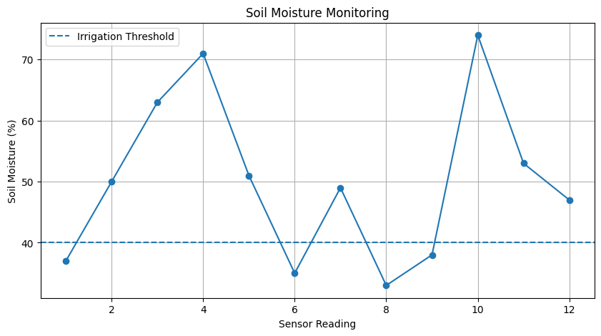
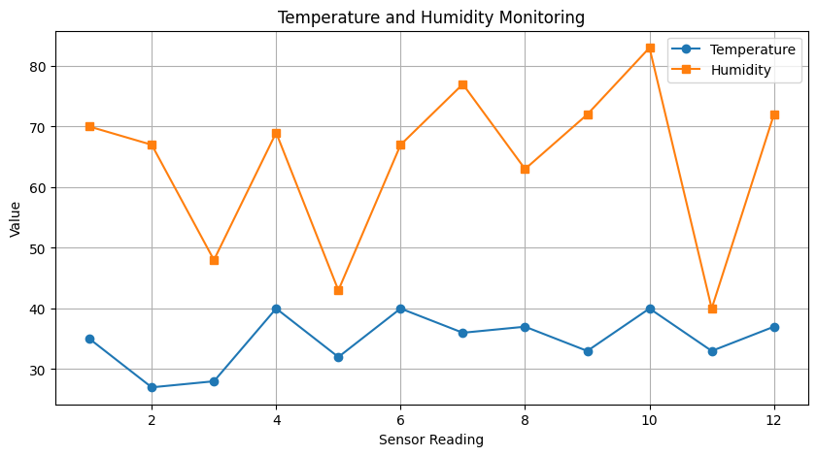
Automated Irrigation System
---------------------------
Reading 1: Soil Moisture = 37% ->Pump ON - Irrigation started
Reading 2: Soil Moisture = 50% ->Pump OFF - Soil moisture sufficient
Reading 3: Soil Moisture = 63% ->Pump OFF - Soil moisture sufficient
Reading 4: Soil Moisture = 71% ->Pump OFF - Soil moisture sufficient
Reading 5: Soil Moisture = 51% ->Pump OFF - Soil moisture sufficient
Reading 6: Soil Moisture = 35% ->Pump ON - Irrigation started
Reading 7: Soil Moisture = 49% ->Pump OFF - Soil moisture sufficient
Reading 8: Soil Moisture = 33% ->Pump ON - Irrigation started
Reading 9: Soil Moisture = 38% ->Pump ON - Irrigation started
Reading 10: Soil Moisture = 74% ->Pump OFF - Soil moisture sufficient
Reading 11: Soil Moisture = 53% ->Pump OFF - Soil moisture sufficient
Reading 12: Soil Moisture = 47% ->Pump OFF - Soil moisture sufficient

Result
The IoT-based Smart Agriculture and Automated Irrigation System was successfully simulated using Python in Google Colab. The system monitored soil moisture, temperature, and humidity and automatically determined the irrigation status based on the soil moisture threshold. The experiment demonstrated the basic working principle of an IoT-based automated irrigation system.

